Art lesson 1

We’re going to be looking at photography this half term.

To get an idea of the history of photography, watch this video, then answer the questions below.

https://www.youtube.com/watch?v=iL7vAC7ActM

- Was there any facts or information in the video that surprised you?
……………………………………………………………………………………………………………………………………….……………………………………………………………………………………………………………………………………………………………….………………………………………………………………………………………………………………………………………………………………………………………………………………………………………………………………………………………………………………………………………………………………………………………………………….……………………………………………………………………………………………………………………………………………………………….………………………………………………………………………………………………………………………

- What are the main similarities and differences between cameras now and cameras 100 years ago?
……………………………………………………………………………………………………………………………………….……………………………………………………………………………………………………………………………………………………………….……………………………………………………………………………………………………………………………………………………………………………………………………………………………………………………………….……………………………………………………………………………………………………………………………………………………………….………………………………………………………………………………………………………………………

- What do you think the next technological advance in cameras might be?
……………………………………………………………………………………………………………………………………….……………………………………………………………………………………………………………………………………………………………….……………………………………………………………………………………………………………………………………………………………………………………………………………………………………………………………….……………………………………………………………………………………………………………………………………………………………….………………………………………………………………………………………………………

- Now complete the worksheet, matching the camera to the decade.

The History of Camera since 1950

Match the pictures of the cameras to the decade you think they came from.
1950s | 1960s | 1970s | 1980s
In 1948, the Polaroid camera, which can take a picture and develop it in 1 minute, is invented. Millions of Brownies cameras are still sold throughout the fifties and in 1957 a version with an integrated flash is released. This decade features many different designs. 35mm film is on the increase but 120 roll film is still used in cheaper cameras. | As electrical components become cheaper SLR cameras begin to be fitted with light meters and automatic exposure. Colour film is available from 1963. Light meters are moved behind the lens to give a more accurate through lens feedback. Cameras are still mostly black with chrome lids. The first cine cameras are produced. | In 1978, the first autofocus point and shoot camera is manufactured. From 1970 until the end of the 20th Century, 35mm film is by far the most popular. Cameras are increasingly mechanised with auto focus and film loading. They are made more often out of plastic. Super 8mm Cine Cameras are used by those wishing to capture moving pictures. | In 1980, Sony begins to sell the first camcorder manufactured for private use. In 1986, Fuji introduce the disposable or ‘single use camera’. By the late eighties and early nineties the first digital cameras begin to appear.

1990s | 2000s | 2010s | 2020s
By the mid-1990s, several companies have produced fully digital SLR and compact cameras which work in conjunction with home computers. Some SLR bases are compatible with existing lens systems. | In 2003, digital cameras outsell film cameras for the first time and the balance continues to shift. In the year 2000, the world’s very first camera phone was introduced. The combination works and manufacturers begin to compete to improve the quality of their phone cameras. | Action cameras, such as GoPro, are launched to enable hands-free picture capture during sports and activities. Cameras that can upload photos wirelessly first began to appear. Lytro cameras are manufactured which enable you to focus images after you capture them and cameras which can ‘see in the dark’ become commercially available for the first time. | Your prediction!

The History of Camera since 1950 Continued
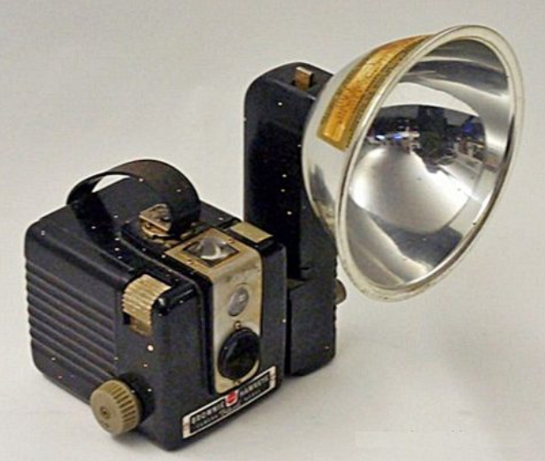
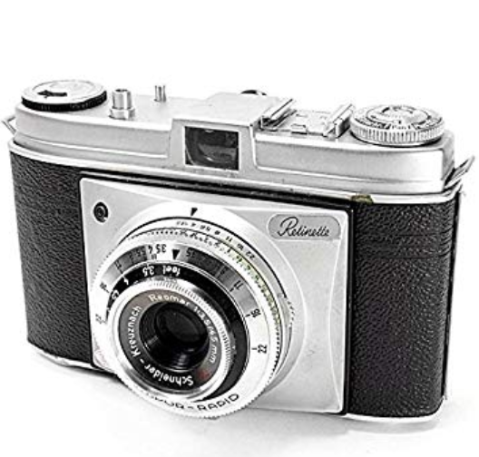
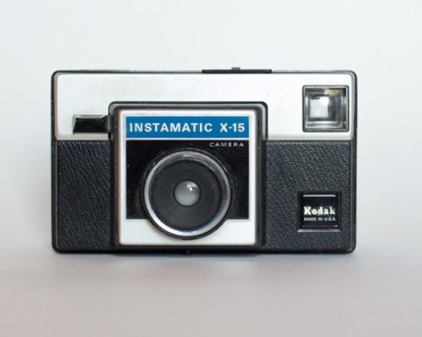
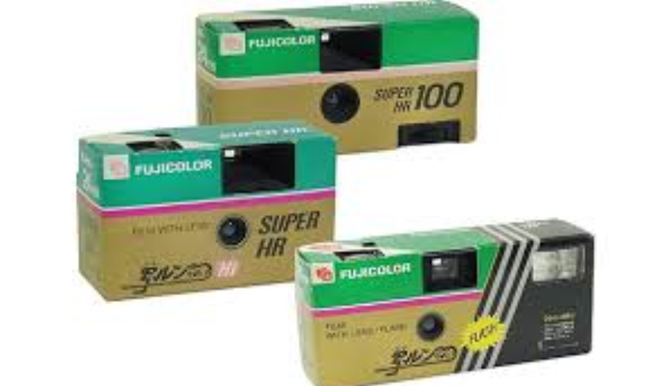
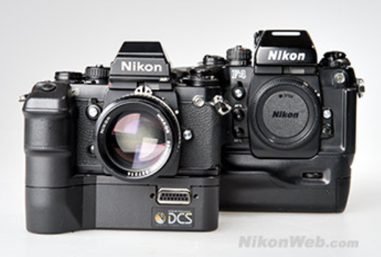
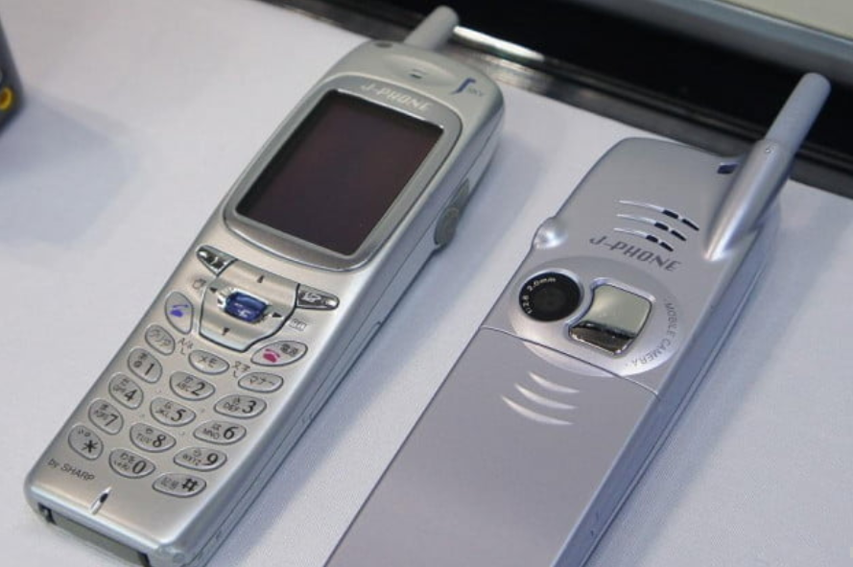
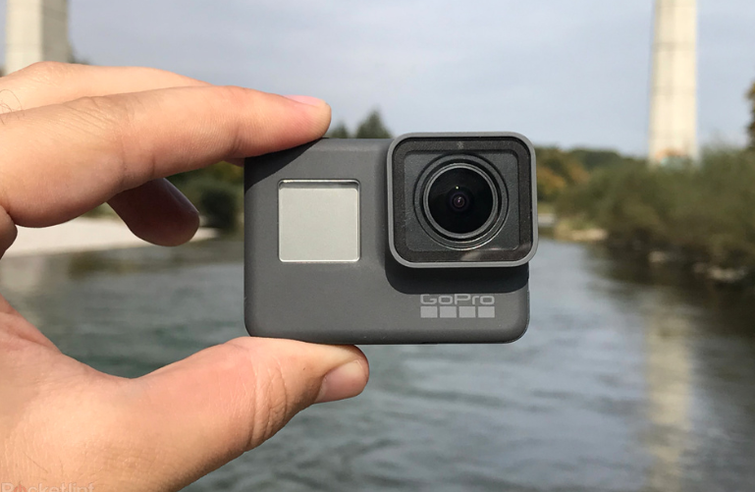
v

