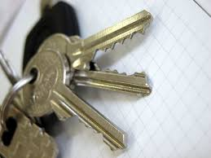
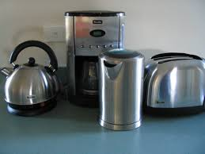
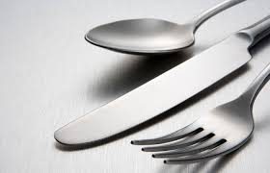

What are all these objects made of?

Can you go on a metal hunt round your house!

Can you find anything different?

Take pictures of your metal objects at home.

Can you remember or research any of the properties of the material metal?

