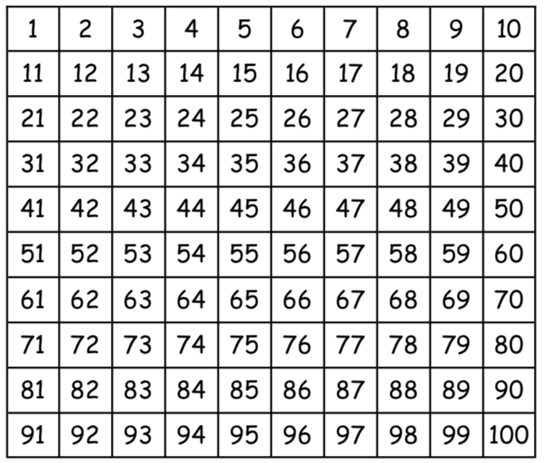
Write down your 10 times tables or colour the numbers in on this 100 square!

