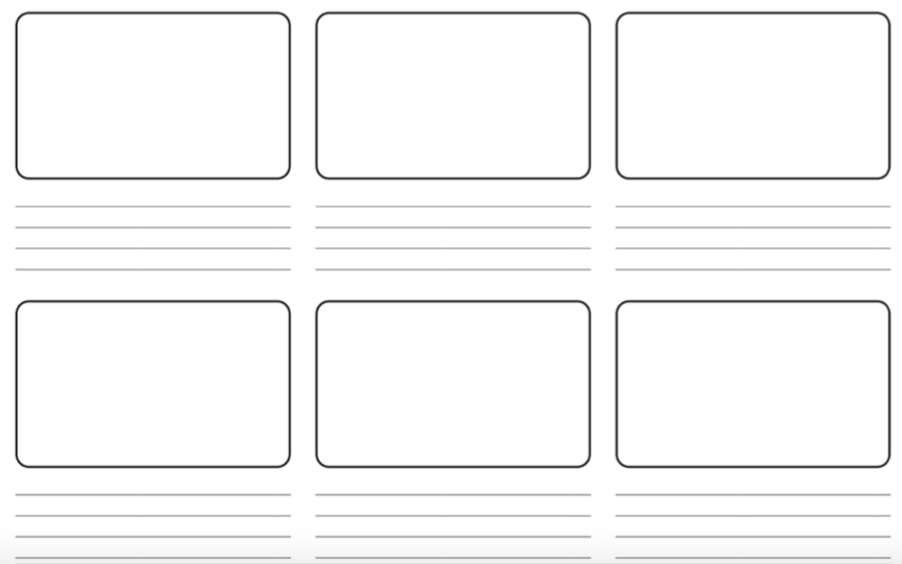
Can you sequence a story by drawing and writing about the main events…

