**Spanish**

1. Teach the adults in your house the numbers song: <https://www.youtube.com/watch?v=8ydJr1Is8xI>
2. 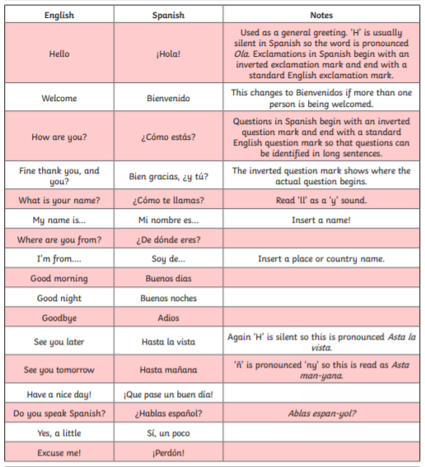Use the following phrases to create conversations.

