Monday | Tuesday | Wednesday | Thursday | Friday
Take 10  Complete 10 minutes of daily physical activity. This could be jogging, aerobics or dancing.  OR Join Joe Wicks on YouTube for daily 30 minute home PE sessions at 9AM. | Take 10  Complete 10 minutes of daily physical activity. This could be jogging, aerobics or dancing.  OR Join Joe Wicks on YouTube for daily 30 minute home PE sessions at 9AM. | Take 10  Complete 10 minutes of daily physical activity. This could be jogging, aerobics or dancing.  OR Join Joe Wicks on YouTube for daily 30 minute home PE sessions at 9AM. | Take 10  Complete 10 minutes of daily physical activity. This could be jogging, aerobics or dancing.  OR Join Joe Wicks on YouTube for daily 30 minute home PE sessions at 9AM. | Take 10  Complete 10 minutes of daily physical activity. This could be jogging, aerobics or dancing.  OR Join Joe Wicks on YouTube for daily 30 minute home PE sessions at 9AM.
Reading  Read a book together. - can you sequence the story by writing or drawing the main parts. | Reading  Read a book and discuss questions such as ‘who’’where’ and ‘what’. | Reading  Choose a picture from https://www.onceuponapicture.co.uk/the-collections/the-inference-collection/  And answer the inference questions! Can you remember what inference means…. USING THE CLUES TO THINK AND WONDER!! | Reading  Read a story to a younger sibling, to a parent or to your teddies!! | Reading  Read a book and draw a story map of the main events and the characters journey!
Maths  Number cards  Get creative and make your own number cards to 100. Use your cards and practice counting in 10s.  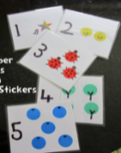  Can you write your 10 times tables? | Maths  Number cards  Use your number cards and practice counting in 2s  Can you write your 2 times tables? | Maths  Number cards  Use your number cards and practice counting in 5s  Can you write your 5 times tables? | Maths  Number cards  Can you sort your number cards in to odd and even numbers.  Put two or three of your number cards together - can you add/takeaway them away from each other. Do this with a sibling or parent - who is the quickest!? | Maths  Can you log into times tables rock stars and practice your, 2s, 5s and 10s times tables.
English Complete a book review for 2 books you have read over the last few weeks.  Draw or write about your favourite part.  Can you compare it to any other stories you know?  Who is your favourite character? Draw or describe them using adjectives! Why do you like them? | English  Can you write sentences with these tricky words. Practise in your best handwriting and include all the joins you know.  Again  Because  Began  Firstly  After  Coming  every | English  Can you write a list of rhyming words  Can you then create your own rhyming poem using these words OR put your rhyming words into sentences.  e.g frog and log  I saw a frog,  Jumping joyfully along the log.  Challenge: can you include verbs, adjectives, adverbs! | English  Check pobble 365 for todays picture of the day.  http://www.pobble365.com  use this to inspire you write. Have a look at the suggested activities with the picture - can you pick one and have a go at it? | English  Make your own playdough!  Then write your own instructions for someone else to follow who doesn’t know how to make it!  Can you take pictures of you making the playdough and add them to your instructions.  https://www.google.com/search?client=safari&rls=en&q=how+to+make+playdough&ie=UTF-8&oe=UTF-8#kpvalbx=_G4V8XojcNsO78gLRu4zwDw38
Spelling  https://spellingframe.co.uk/  Play –Year 2  Spelling rule- 28 homophones – You can practice then take a mini test!  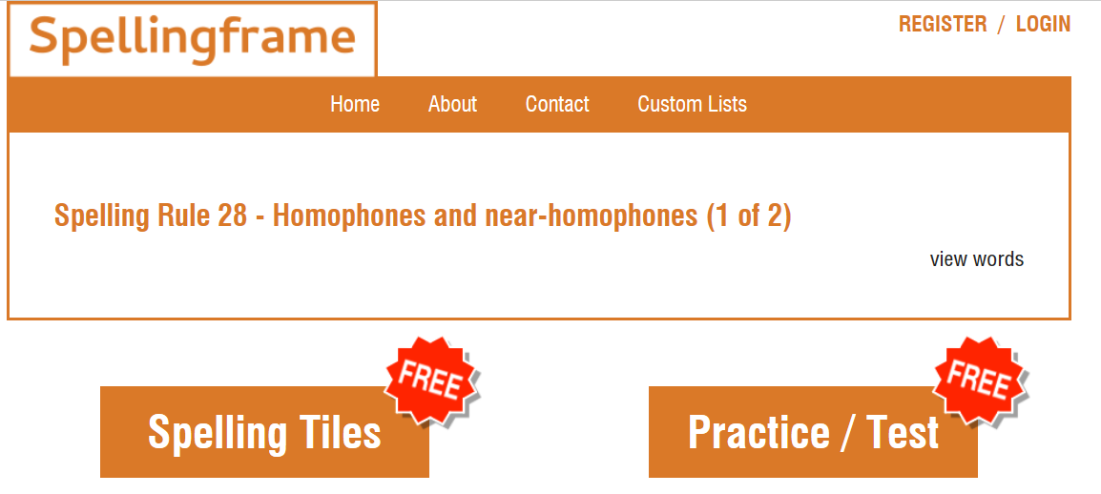 | Handwriting  See above  Remember these joins  Ir, er, ai, ly, ng, | Spelling  https://spellingframe.co.uk/  Play –Year 2  Spelling rule- 29 homophones – You can practice then take a mini test! | Handwriting  Practice the joins below. Can you think of any words which have these joins?  ch, th, ck, | Spelling  https://spellingframe.co.uk/  Play –Year 2  Spelling rule- 30- Common words (set 1)  – You can practice then take a mini test!
Topic  Learn a new skill such as  - Tie your shoe laces  - Simple cooking - butter your toast, make a fruit salad, make a sandwich.  - Help with the laundry/  - Wash some dishes independently  - Hoover or dust some shelves. | Topic  Science – draw 5 plastic objects in your home. Can you add in their properties? | Topic  ICT  Check your purple mash for any tasks or activities set by your teacher. | Topic  Science – draw 5 wooden objects in your home. Can you add their properties? | Topic  Science - draw 5 metal objects in your home. Can you add their properties?
Story time  Ask your parent/ carer/ sibling to read to you. | Story time  Choose and listen to a story onhttps://www.storylineonline.net | Story time  Read your parent a story at bedtime. | Story time  Ask your parent/ carer/ sibling to read to you. | Story time  Ask your parent/ carer/ sibling to read to you.
Mindfulness  Enjoy a quiet session of mindfulness. Join gonoodle and select an activity.  https://family.gonoodle.com/channels/flow | Mindfulness  Go on the school website and select wellbeing in the home learning section. Choose a mindfulness activity | Mindfulness  Enjoy a quiet session of mindfulness. Join gonoodle and select an activity.  https://family.gonoodle.com/channels/flow | Mindfulness  Go on the school website and select wellbeing in the home learning section. Choose a mindfulness activity | Mindfulness  Enjoy a quiet session of mindfulness. Join gonoodle and select an activity.  https://family.gonoodle.com/channels/flow

Links to websites
Cross curricular activities - Purple mash – Check for Alerts to see if the year 2 teachers have sent you an activity.
Twinkl – Think about all the subjects you find challenging, can you find some extra work to complete to support your learning.
Maths: TT Rockstars https://play.ttrockstars.com/auth - use this to improve your multiplication.
Science: https://explorify.wellcome.ac.uk/ - have a look and see if you can complete a fun science experiment
Woodland Trust
Activities for children if you are self-isolating
https://www.woodlandtrust.org.uk/blog/2020/03/kids-nature-activities-self-isolation/

DT – Food Tech
Some ideas for getting children involved with cooking
https://www.bbcgoodfood.com/recipes/category/family-kids
https://www.bbcgoodfood.com/recipes/collection/kids-cooking
https://www.bbcgoodfood.com/recipes/collection/kids-baking
https://realfood.tesco.com/recipes/collections/easy-recipes-for-kids.html

Joe Wicks – PE for kids
And just in case you’ve missed this. A daily session for children
https://www.thebodycoach.com/blog/pe-with-joe-1254.html

Spellings:
https://spellingframe.co.uk/

If you need any help with the work please email the school office office@keysmeadow.enfield.sch.uk
Your message will be forwarded and returned by the class team as soon as possible.

