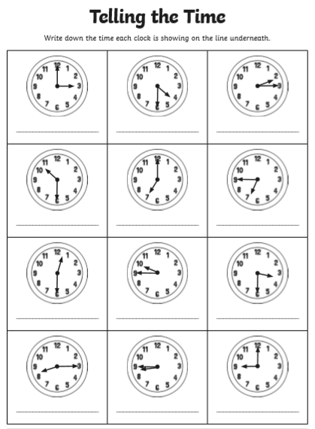
Key words: -
O’clock, Half past, quarter past , Quarter to

