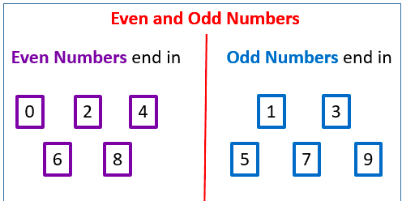
THEN…
Pick two or three of your number cards - can you add/takeaway them away from each other.
Challenge: Do this with a sibling or parent - who is the quickest!?

Can you sort the number cards you made earlier on in the week into odd and even numbers..
Don’t forget…

