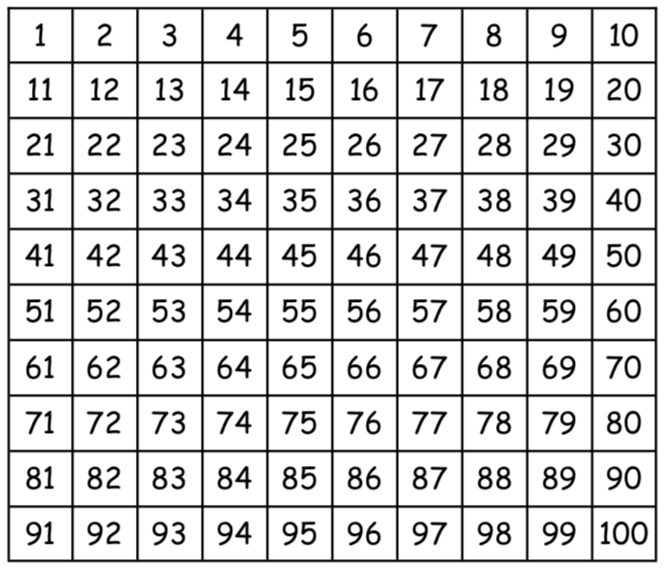
Write down your 2 times tables or colour the numbers in on this 100 square!

