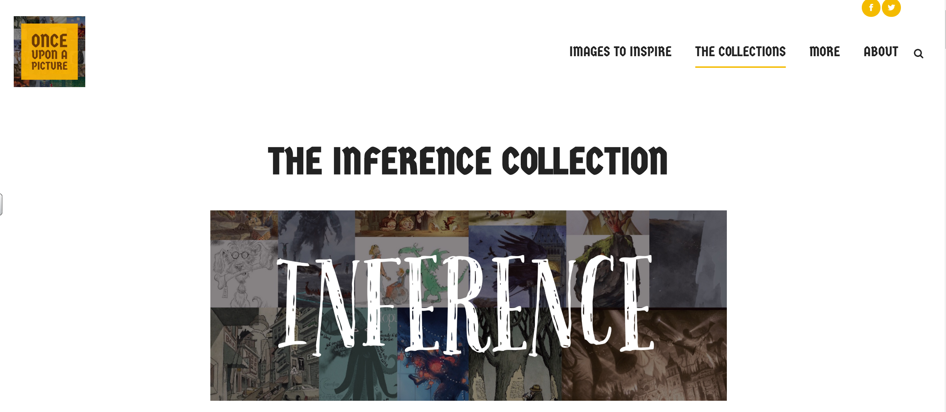
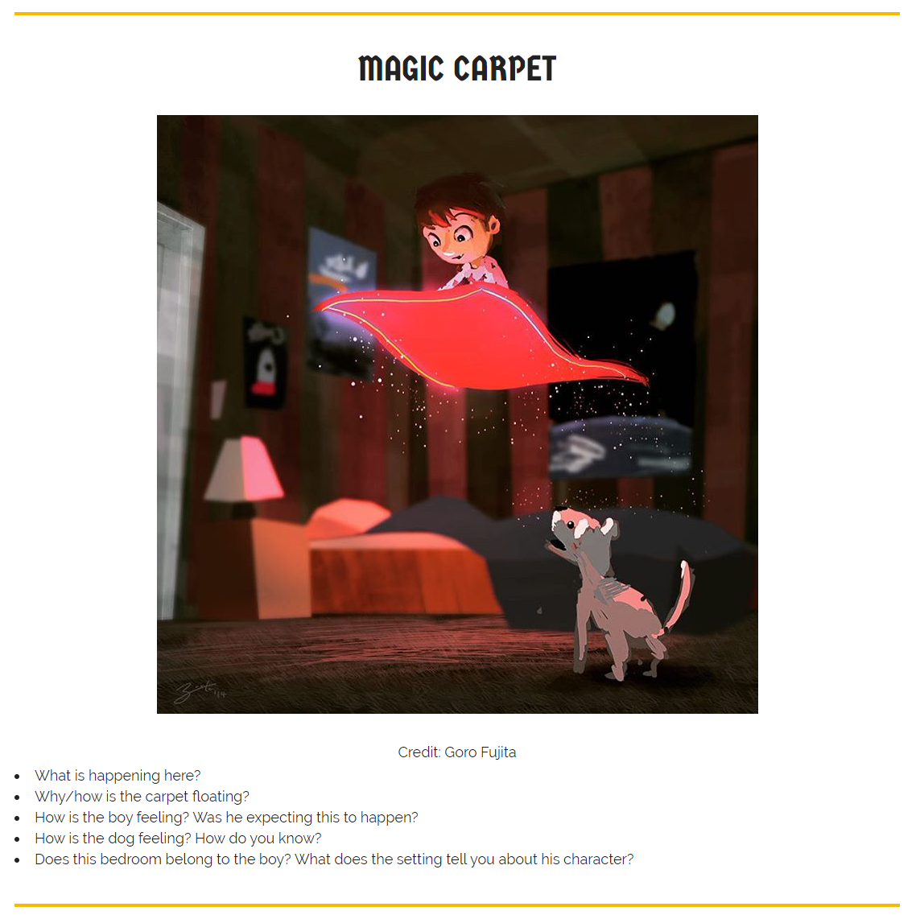
Look at the picture and answer the questions below.
You can use this picture or choose your own from the website

