**Art lesson 2**

This week we’re going to be thinking about portrait photography.

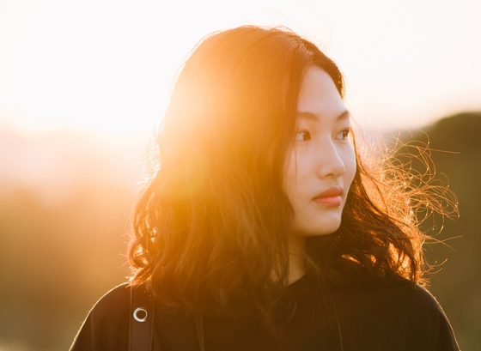Have a look at the portraits below.

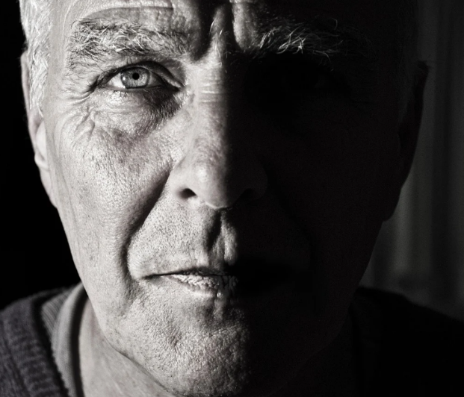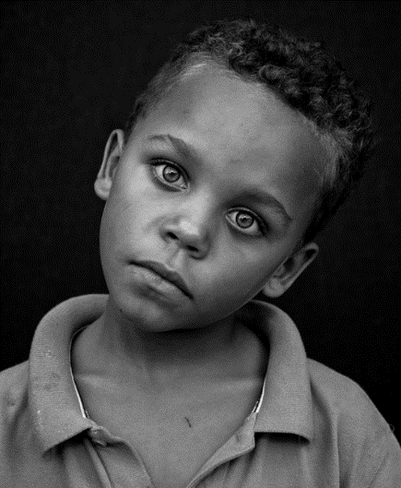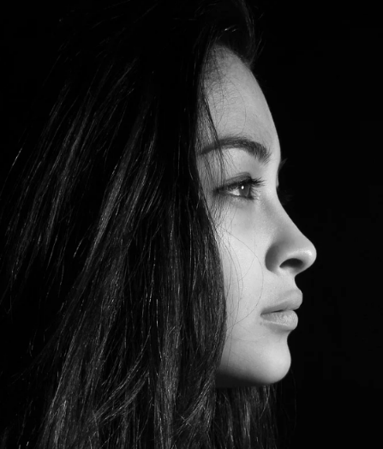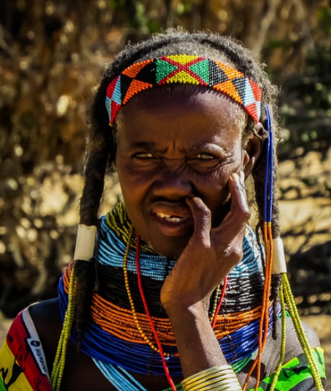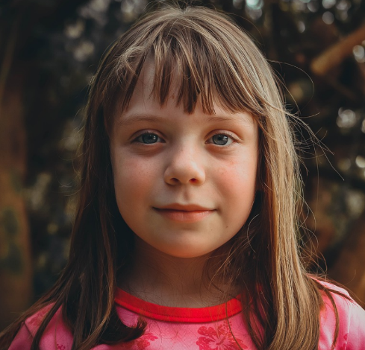

What do you think makes a successful portrait? What do you think the photographer needs to think about when setting up a portrait photo? Think about what all the photos above have in common to help you.

____________________________________________________________________________________________________________________________________________________________________________________________________________________________________________________________________________________________________________

Using any camera that you have access to, try to take a portrait of yourself or someone in your home (with their permission). Think about things like:

* The lighting
* The background
* Whether you want it in colour or black and white
* Whether you want to experiment with filters or adjusting the colour balance or light and dark.

When you’re happy with your portrait, upload it along with this work.