**Science - Lesson 2**

1. 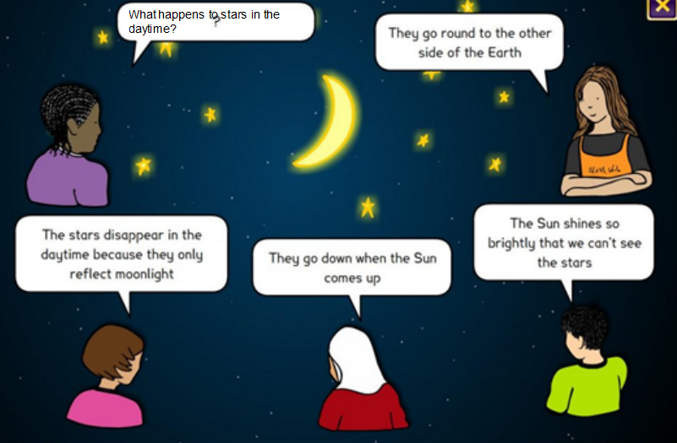Have a look at the concept cartoon below.

Who do you agree with?

Can you explain why?

1. Watch the video ‘Why can I see the moon during the day’ on the channel SciShow Kids at <https://www.youtube.com/watch?v=-Oyv3Qg4a8k>

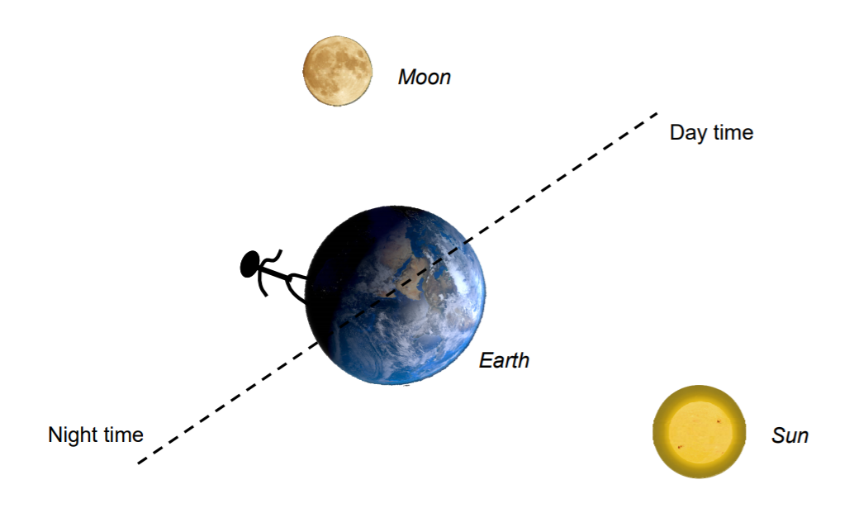Draw in arrows to show how light from the sun enables us to see the moon.