**Spanish – lesson 2**

Practice the numbers 1 to 20 using this video on youtube, called Numbers 1-20 in Spanish, by SpanishBasics

<https://www.youtube.com/watch?v=hnzaChYqXUY>

Try singing along to the numbers in this song called Spanish Numbers Song 1-20 on the channel Learn Spanish through Music

<https://www.youtube.com/watch?v=zzhHrQbHZMA>

Try these sums, writing your answer in Spanish!

1. Nueve – cinco =
2. Cuatro + doce =
3. diecisiete – uno =
4. Seis x dos =
5. Veinte ÷ cuatro =
6. Catorce – seis =
7. Dieciseis + cero =
8. Diecinueve – siete =
9. Uno x diez =
10. 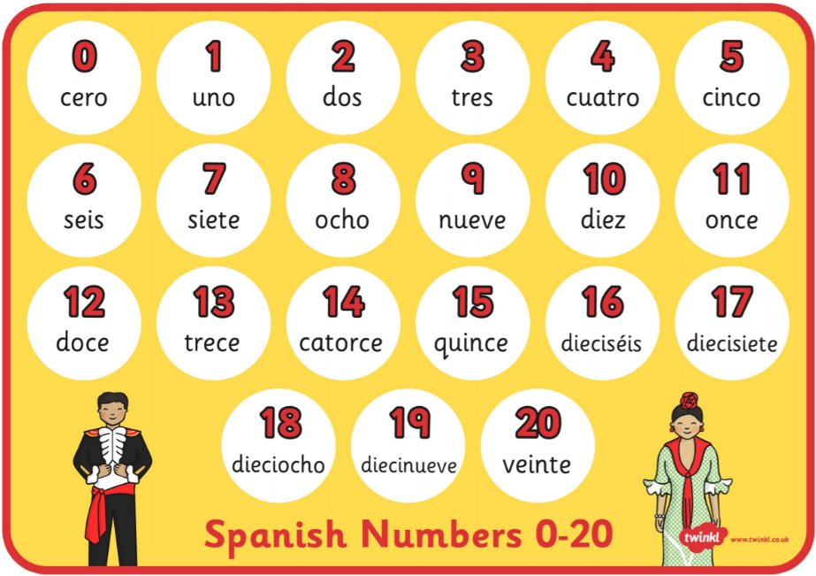Dieciocho ÷ nueve =