**Art – lesson 4**

**Still life photography**

Still life photography is the depiction of inanimate objects. Because the artist hasn’t got to worry about the subjects running away, they have a lot of control about the lighting and composition of the photo.

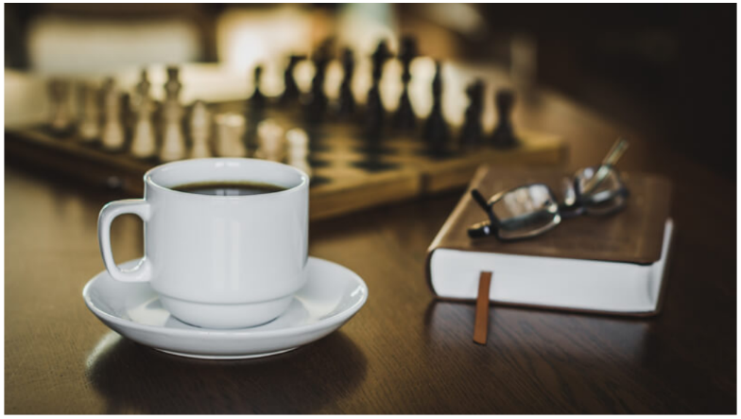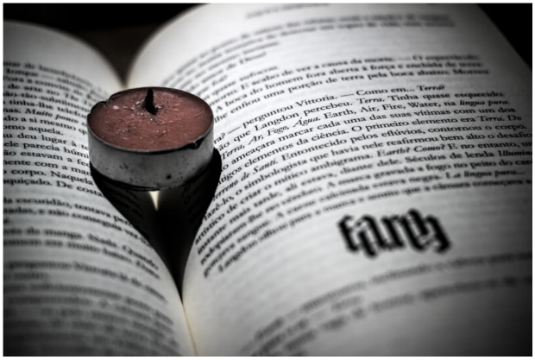Have a look at these pictures.

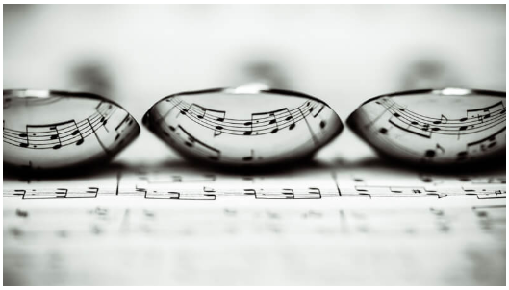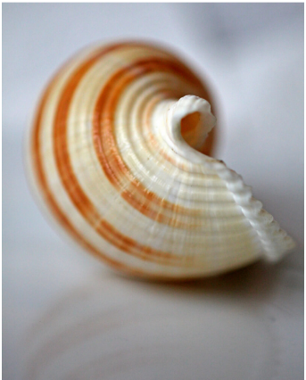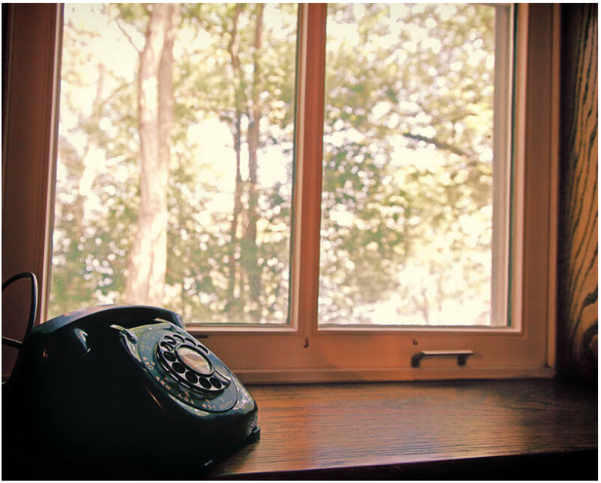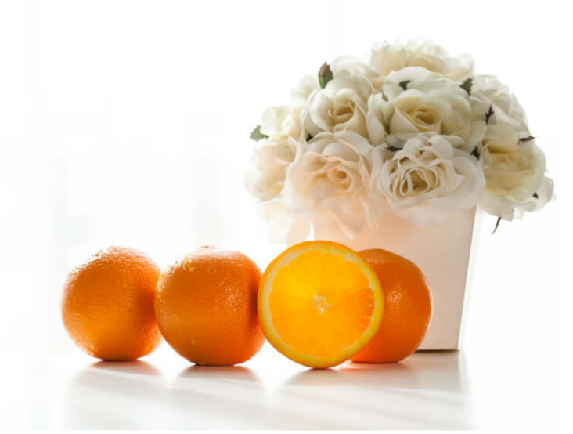

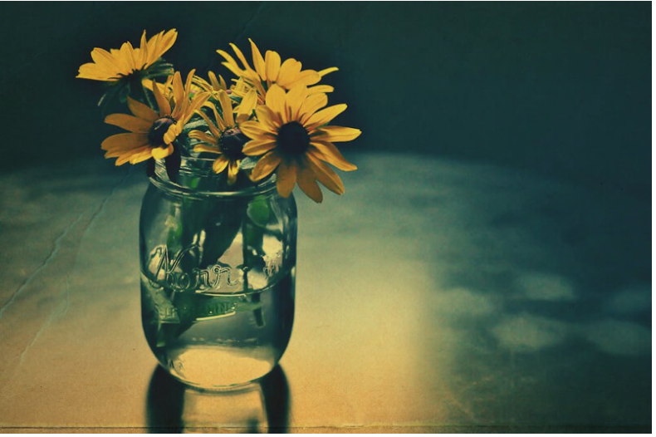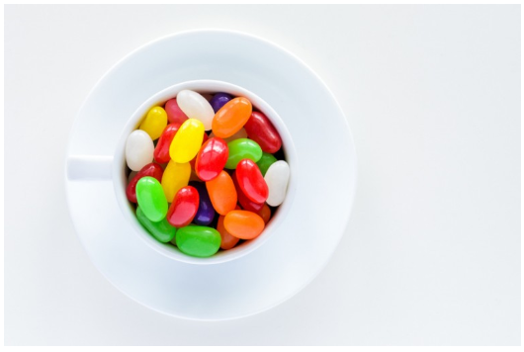

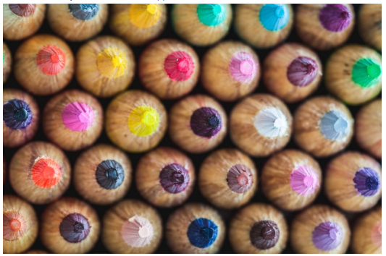

1. Choose a couple of objects in your house that you can use to create a still life. You could use some of your toys, cutlery, mugs, glasses or plates, clothing, ornaments or flowers, things you find the garden or outside. You might want to choose things that might have an interesting colour, or texture, or will reflect light.
2. Think about where you’re going to set up your picture. Do you want to have a blank background, like some of the photos above, or do you want to have something in the background. How much light do you want? Do you need to position your picture near a window, or do you want to position it somewhere dark where you can use a flash to create an effect. Do you want to take your picture in black and white or colour? Think about any reflections in the photo.
3. Finally, think about the composition. Take care to position your objects carefully. If your camera allows, think about what is going to be in focus and what is not.
4. Experiment with different composition, lighting, effects until you’re happy with the picture you’ve taken.

What did you find difficult about creating a still life?

____________________________________________________________________________________________________________________________________________________________________

What did you enjoy about creating a still life?

____________________________________________________________________________________________________________________________________________________________________