**Art – lesson 3**

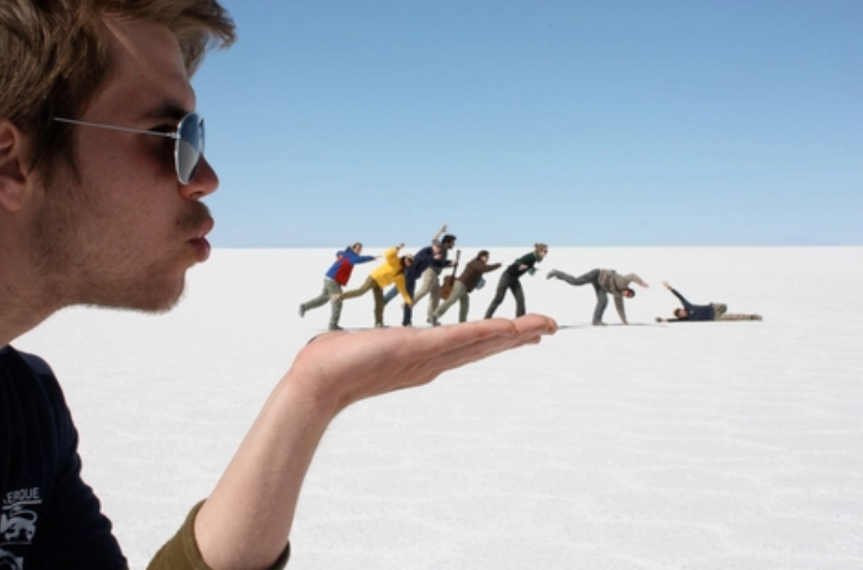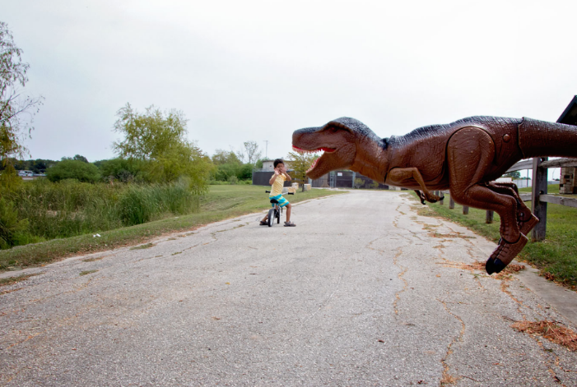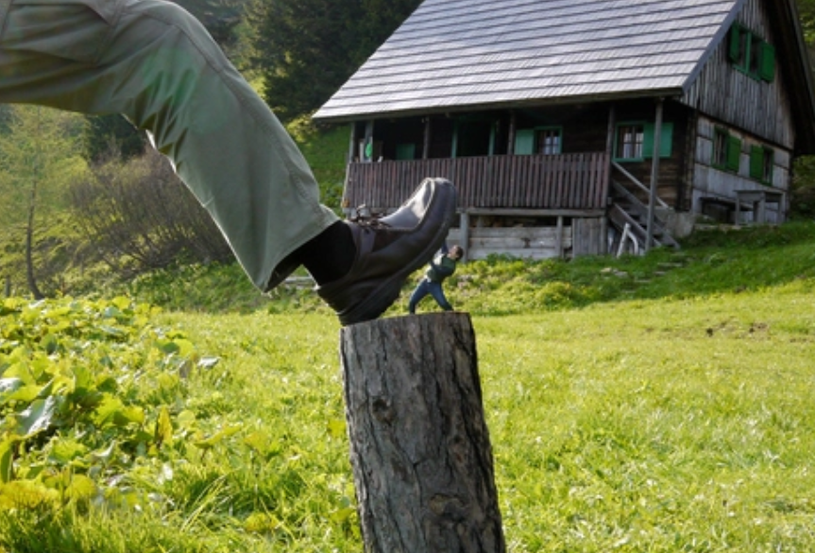Have a look at these photos. What is so strange about them? How do you think they’ve been created?

They use a technique called ‘forced perspective’. For more information, watch the video called

Forced perspective photo tricks for kids by Matt Farrell on <https://www.youtube.com/watch?v=a7KnUftc_3Q>

Have a go at creating your own illusion photos using forced perspective and upload your results onto your folders!