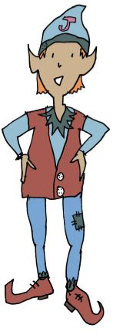
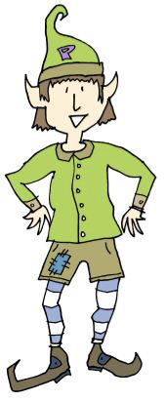
Can you make up your own riddle about an animal?

Here’s what to do: Choose your animal
Write a list of things you know about the animal. Turn the list into a riddle like the elves did in the example.

Here is Miss Price’s idea to get you started:
My animal: Crocodile
List of things I know about the animal: Sharp teeth, long snout, swims fast, live in rivers or lakes, cold blooded, strong bite, scaly skin, webbed feet
My riddle
What am I?
Fast swimmer, Lake liver. Long snouter, Strong biter.

Your turn:
My animal:
List of things I know about the animal:
My riddle

