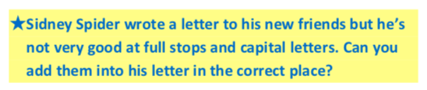

dear spiders,
thank you for keeping me safe from mrs brown’s broom she nearly swept me into her dustpan I had a lovely time at our spider party I’m very happy to have some new spider friends and I’ll help you when you have a problem
love Sidney xx

