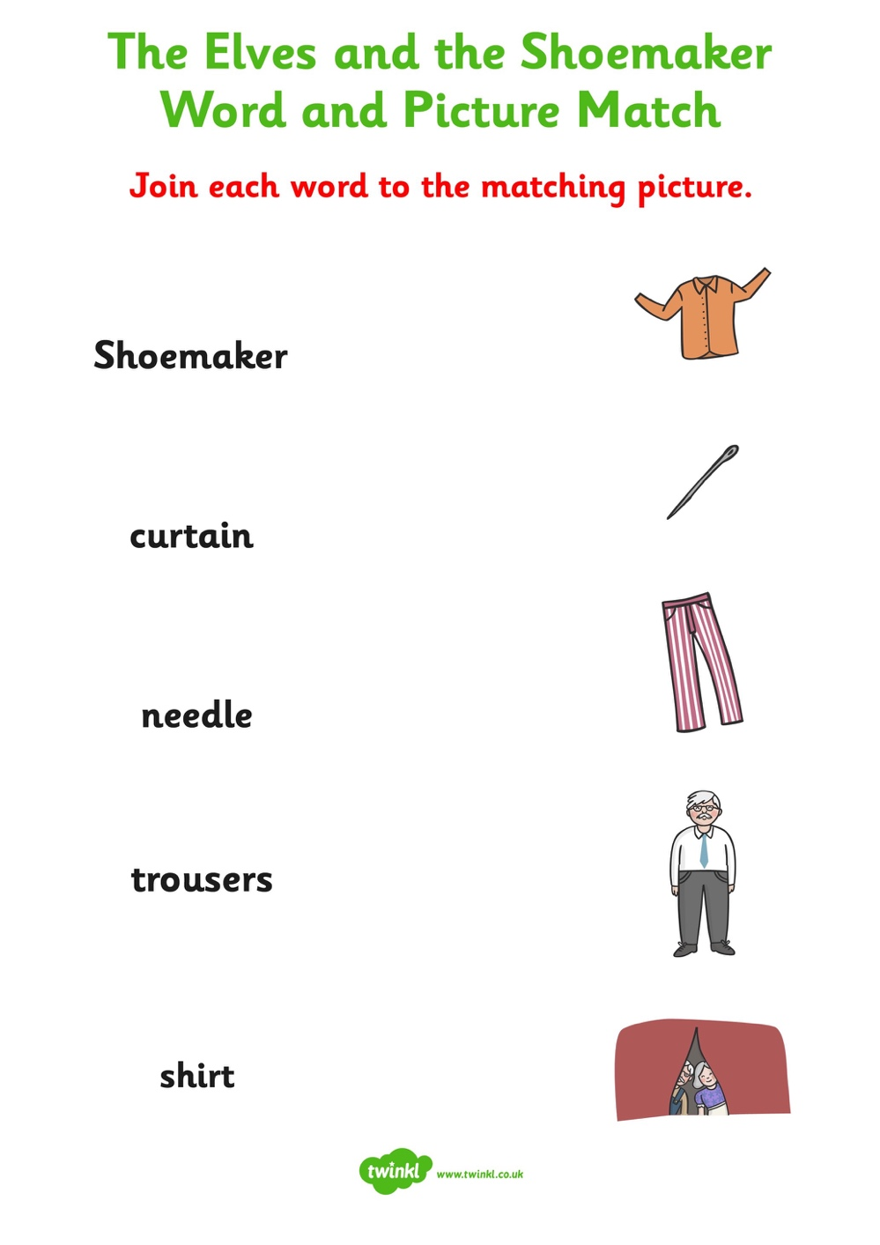

Can you now write each word in a sentence? Can you include some conjunctions to extend your sentences? and, but, because, or, so

