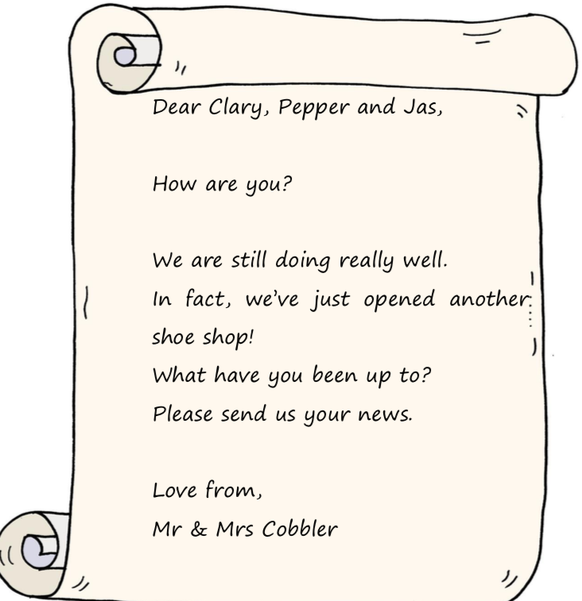

Clary, Pepper and Jas have been on lots of adventures. Can you now write a letter to Mr and Mrs Cobbler, telling them what the elves have been up to?
Dear Mr and Mrs Cobbler,

