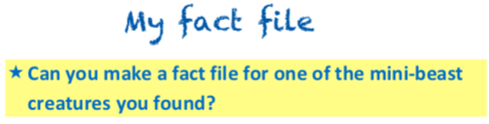

What it looks like
Where it lives
What it eats
An unusual fact
Other interesting facts


