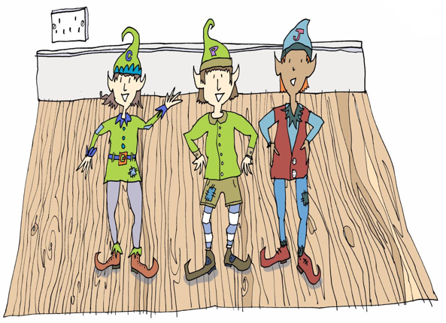
Clary, Pepper and Jas want to know all about your investigation into whether materials are strong and waterproof.

★Can you write:
✓some instructions for them to follow?
✓What you predicted and then discovered as a result of your investigation? Use the sentences starters below for support if you need.

How to investigate whether materials are strong and waterproof

- What you need:

- What you do:

My investigation
- Before I started, I predicted that ...
would be the strongest and most waterproof.

- I found that ...

