Punctuation activity

Can you name all the punctuation below.
Talk to an adult about when you would use each type of punctuation.


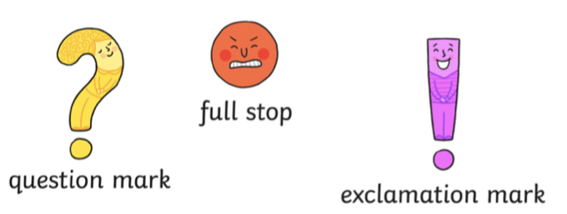

Capital letters

Now look at the pictures of Mavis the Magic Cat - write some sentences including all punctuation.

Here is one for you

Is Mavis stuck in the tree?

