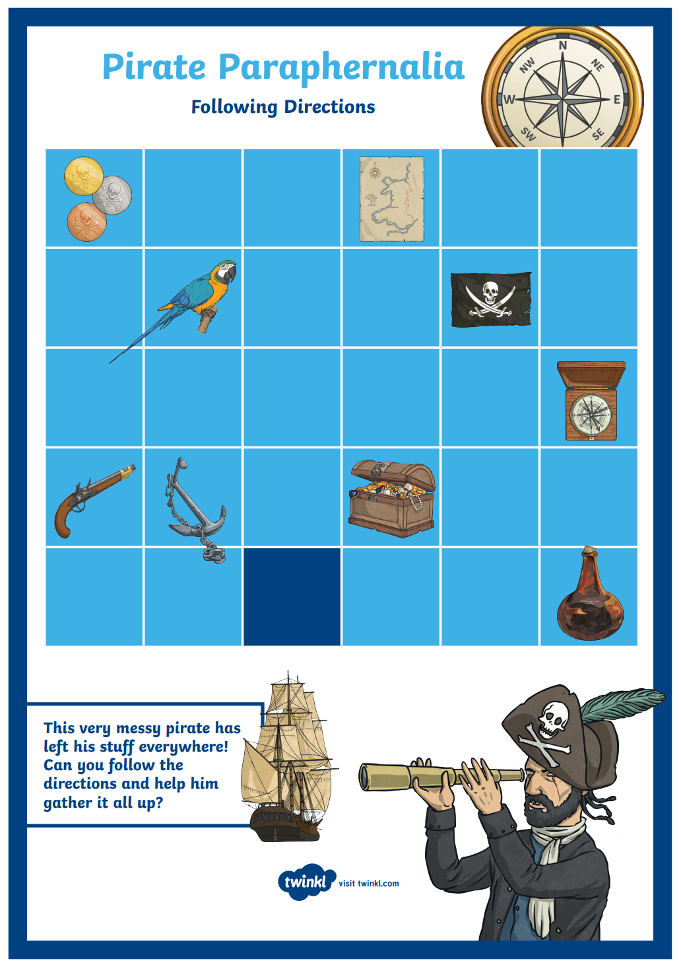
This very messy pirate has left his stuff everywhere! Can you follow the directs and help him gather it all up?
You need to start on the dark blue square
Lost Items
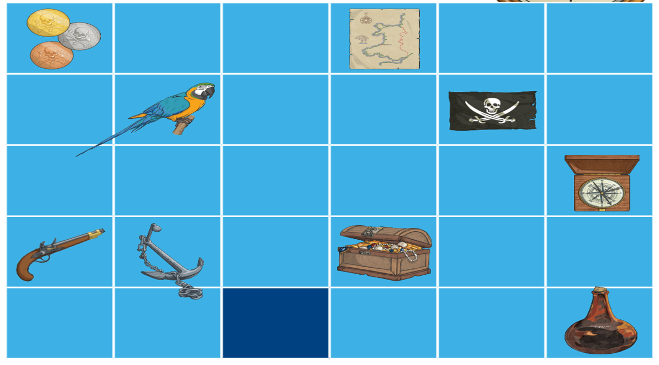
- Forward 1, left 2 =

- Right 2, Forward 3 =

- Left 1, forward 2, left 1, forward 2, right 2 =

- Left 2, forward 3, right 1, down 2 =

- Forward 4, right 2, down 3, left 1 =

- Forward 1, right 3, back 1 =

- Left 1, forward 2, right 2, forward 1, right 2, back 1 =

- Right 2, forward 2, left 4, forward 2 =

Which object haven’t you found? _________________

