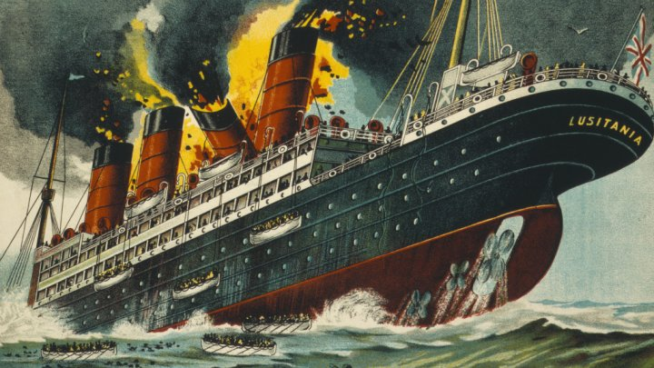

On May 1st 1915, the RMS Lusitania left New York for Liverpool with 1,266 passengers and 696 crew members on board. It was to be her 201st crossing of the Atlantic and she was the fastest ship of her time. Unfortunately, World War One had broken out one year before so the waters around the UK were very perilous for a cruise ship to go into.

Surprisingly, the Lusitania made it all the way across the Atlantic safely. However, it wouldn’t be long before the ship would meet an explosive ending. Just off the coast of Ireland, the ocean was helping to conceal a dangerous secret. A German submarine (U-20). At 2.10pm, the submarine launched a torpedo at its unsuspecting target. Violently exploding under the front of the ship, it sent wooden lifeboats flying in all directions. Mysteriously, a second, even bigger explosion followed…but no one knew why. The German submarine had only fired one torpedo, how did two explosions happen?

Within 18 minutes, the Lusitania had sunk to the bottom of the sea. 1,193 passengers perished that afternoon and only 763 survived. No other ship would dare go and rescue people until the coast was clear. Germans were considered criminals for blowing up an innocent ship. Or was it innocent?