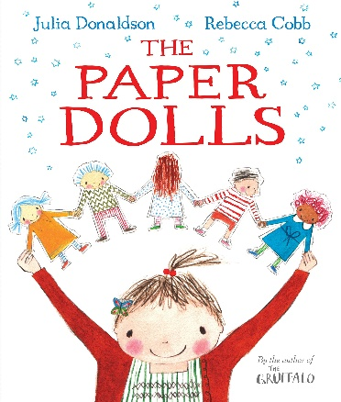
- How many goldfish did the little girl have?

- What did the paper doll Jo have?

- Can you find 3 verbs on this page?
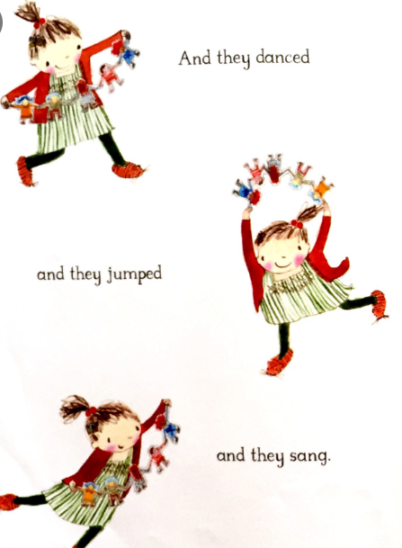

- What animal did they meet first? What was he going to do?

- What did the dolls do with the pigs at the farmyard?

- Where did the paper dolls explore?

- What word described the crocodile?

- What did the little boy do to the dolls?

- Where did the dolls go after?

- What did they find there? Can you list 4 things.

