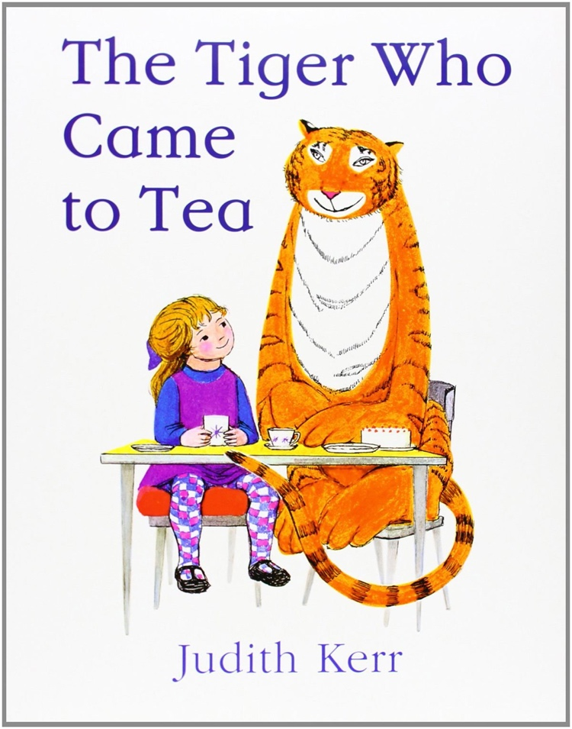
Listen to the story read by Munuse.

Then discuss these questions with an adult.

You can then have a go at answering them.

What did you like about the story?

What was your favourite part?

What does the story remind you of and why?

