Share the story Sidney the Spider with a grown up and discuss the story together.
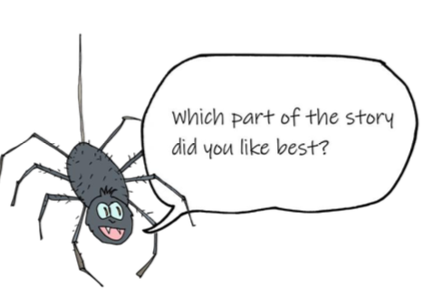
Then fill in these boxes.
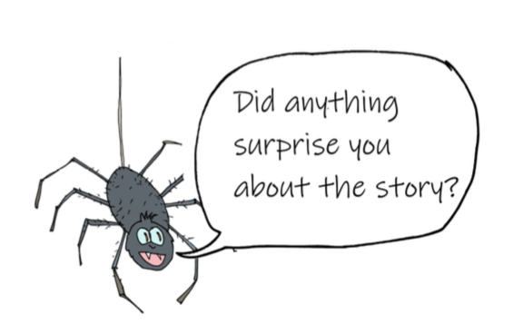
I was surprised by…
I want to know…
I liked…

