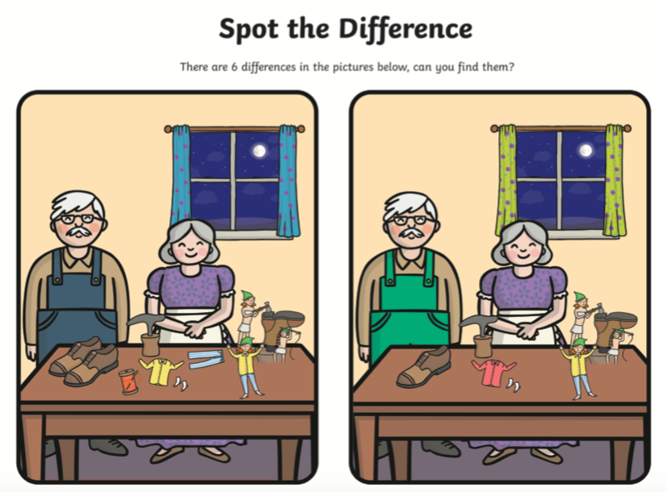

Write down the differences that you can see:

e.g the curtains are different because one is blue and one is yellow.

