Here are Four verbs (action words) from the poem:

Splashing
Running
Dripping
Plucking

Can you read them?
What do they mean?
Which picture would match which verb?
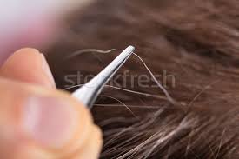
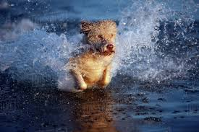
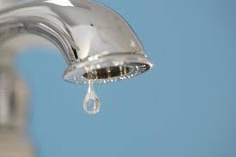
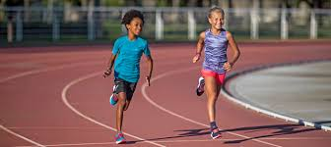

Can you write the verbs in a sentence? Don’t forget your capital letters and full stops!

Here is one for you:

I was splashing through the big puddle.

