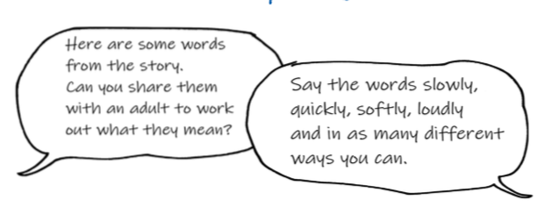

Ancient – something that is very old.

Prey – an animal that is hunted or killed for food.

Can you now…

Find four things in your house that are ancient?

Name four animals that hunt for their prey?

