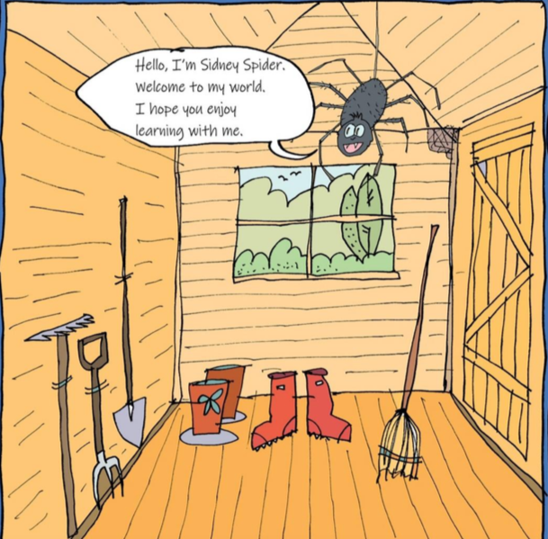
Sidney Spider – A Tale of Friendship
Once upon a time, there was a large spotted spider called Sidney who lived in the top corner of Mrs Brown’s shed. He was a very special spider because he spun beautiful golden webs, but Sidney was lonely. When he arrived last year, all the other spiders said, “Go away, Sidney. We don’t want you here. You’ll steal all our prey with your golden webs.” So, Sidney hid away in his dark corner feeling sad.
One bright, sunny morning, Mrs Brown decided to spring clean her shed. So, she opened up the door and banged her broom, feather duster and dustpan down on the floor. Sidney and all the other spiders in the shed shivered in fear. Soon, Mrs Brown started to sing Incy Wincy Spider at the top of her voice and Sidney shivered a bit more. Then Mrs Brown picked up her broom and started to sweep: swish, swash, swish, swash, swish, swash.
Sidney looked down from his deep, dark corner and saw Mrs Brown’s broom coming closer and closer and closer: swish, swash, swish, swash, swish, swash. “Help!” cried Sidney. “Please help me.” Luckily, Susie, a tiny house spider, heard him. “I’m in the old flowerpot behind the spade,” squeaked Susie. “Throw out your line and come and hide with me.” So, Sidney threw out a fine golden thread and landed gently in Susie’s flowerpot. “Thank you, Susie,” said Sidney smiling.
A few minutes later, Sidney and Susie heard: swish, swash, swish, swash, swish, swash. Oh no, Mrs Brown’s broom was heading for the flowerpot. “Help!” cried Sidney and Susie. “Please help us.”
Luckily, Stanley, an ancient spider, heard them. “I’m in the red welly boot under the bench,” mumbled Stanley. “Throw out your line and come and hide with me.”
So, Sidney threw out a fine golden thread and grabbed Susie. Together they landed with a gentle thump in the old red welly boot. “Thank you, Stanley,” said Sidney and Susie smiling.
A few minutes later, Sidney, Susie and Stanley heard: swish, swash, swish, swash, swish, swash. Oh no, Mrs Brown’s broom was heading for the red welly boot. Mrs Brown bent over to pick up the boot but, luckily, her phone rang at that very moment. “I will come immediately,” they heard her say. So, Mrs Brown picked up her broom, feather duster and dustpan and rushed out of the door.
“Hooray!” said Sidney, Susie and Stanley. “Come on everyone, let’s have a party!” they said.
So, all the other spiders crawled out of the holes. First, they all shook one of Stanley’s legs to welcome him. Next, they danced a special spider dance in the middle of the shed. After that, Stanley knew that he would never be lonely again.

