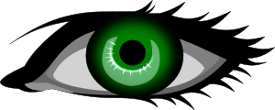**Labelling the parts of the eye**

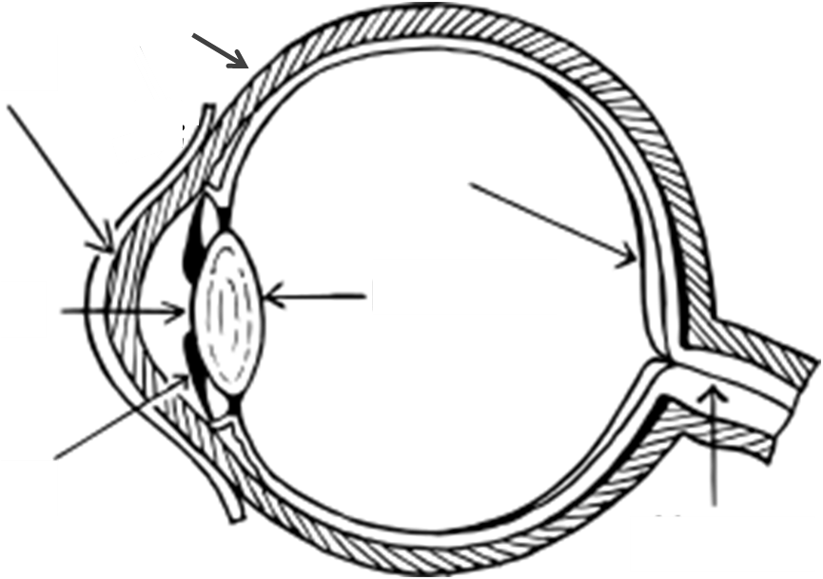

|  |  |  |
| --- | --- | --- |
| Cornea |  | A transparent coating which covers the iris and the pupil at the front of the eye. It also helps the eye to focus by refracting the light (changing its direction). |
| Optic nerve | Sends signals from the eye to the brain, which represent colour, light and dark. The brain can then interpret these into what we see. |
| Iris | The coloured part of the eye, which has tiny muscles to control how much light enters the pupil. |
| Retina | Contains photoreceptors, which are sensors that change light into electric signals for the brain. |
| Lens | Has the job of focusing light onto the retina at the back of the eye. It refracts the light, causing the image to be upside down on the retina. |
| Pupil | The hole in the centre of the eye, which allows light to enter. The pupil gets bigger when it is dark, in order to allow more light into the eye. |
| Sclera | The 'white of the eye'. The strong outer coating of the eye, which also controls its movement through six tiny muscles. |

**Experiment to try at home.**

We see when light from a light source bounces off an object and into our eyes. The light enters our eyes through the pupil. The Lens then focuses the light on the retina at the back of the eye where the information is relayed to our brain via the optic nerve.

You will need a mirror and a window with curtains or blinds.

Stand near a window in daylight and look closely at your eyes. Pay particular attention to the size of your pupils.

Close the blinds or curtains, or go to a much darker room. What has happened to the size of your pupils?

Why do you think the size of your pupils change as the level of light changes?