Spanish – lesson 4

Watch the video at <https://www.youtube.com/watch?v=SQbspMMdJU8>

7 days of the week in Spanish on Jack Hartman’s Kids Music Channel.

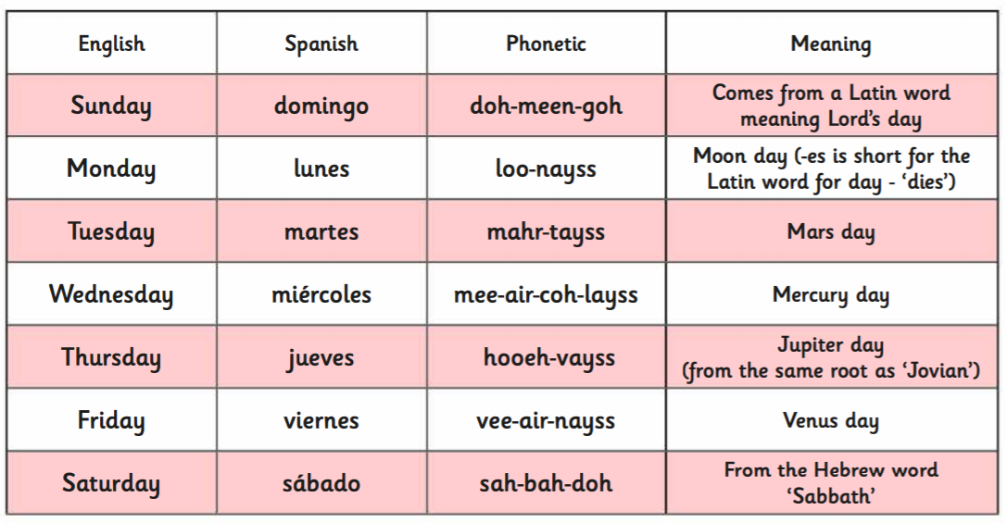

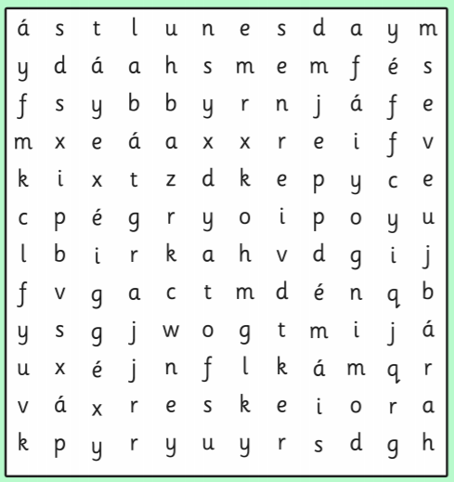Can you find all the days of the week in Spanish in this wordsearch? (Go to insert and select the shapes button. This will give you the option to draw lines to join the ltters)