Spanish – lesson 5

Listen to the song about the 12 months of the year (doce meses del año)

<https://www.youtube.com/watch?v=IKznbHvPFwc>

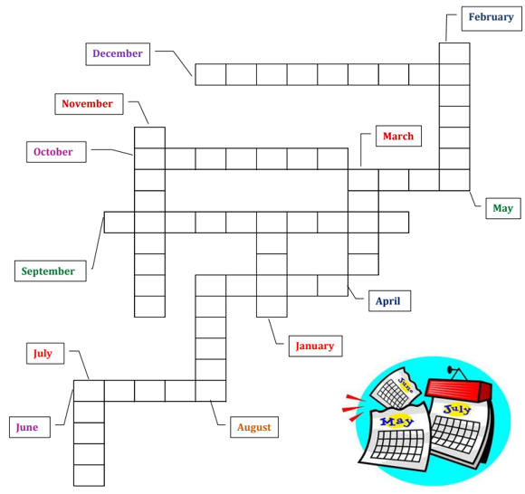

**Challenge:**

Can you create a wordsearch or crossword for any of the Spanish vocabulary you’ve learned over the last 5 weeks?