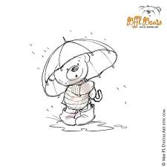
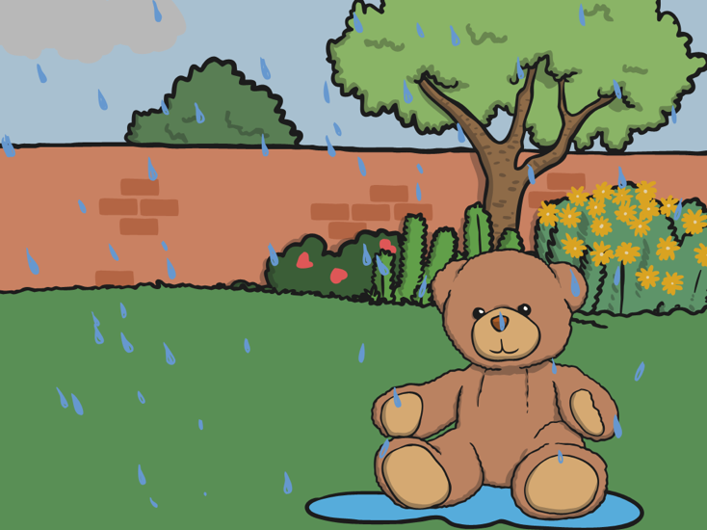

Can you write about your umbrella and the experiment you did yesterday?

What went well?

Did your teddy stay dry?

Why? Why not?

What do you need to do differently next time?

