Time to start thinking about your Magic Box you will make on Friday
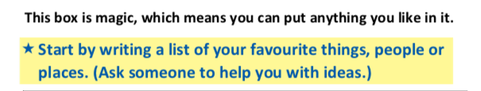

My ten favourite things, people or places are:

1.
2.
3.
4.
5.
6.
8.
9.
10.

