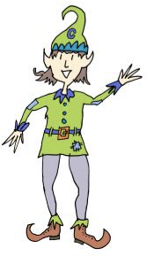
★ The elves need some new clothes! Could you design three new hats, suits and pairs of shoes?

Use lots of colour and patterns! Get creative!

