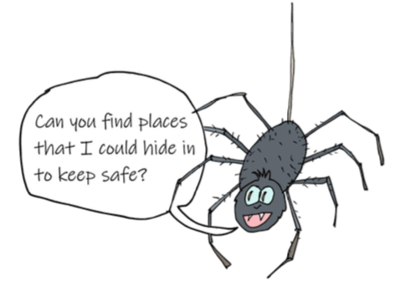
Go on a hunt around your house or in our garden…

Use these sentences starters or challenge yourself and write your own.

I could hide in a

I could hide in a

I could hide under a

I could hide on top of a

I could hide next to a

