Umbrella experiment!

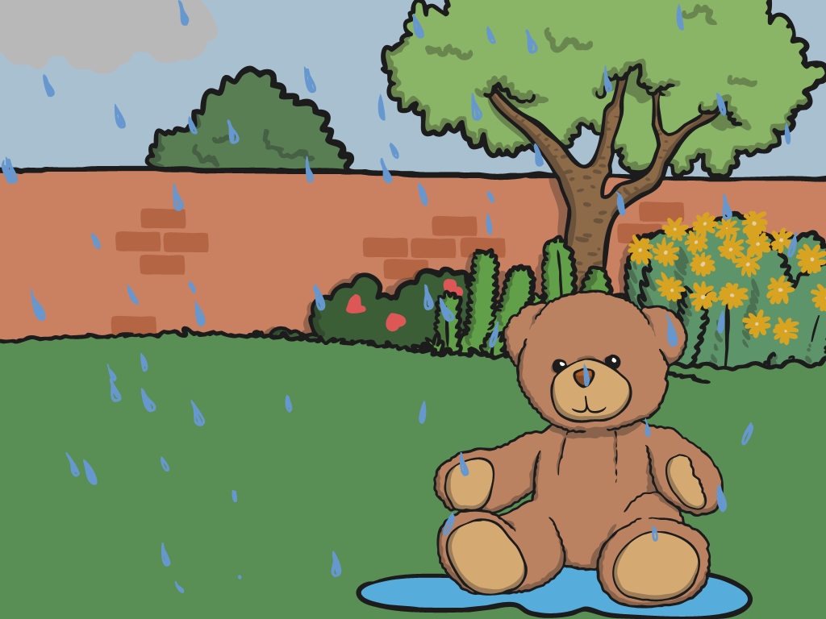

Put a teddy or something under the umbrella you made yesterday. Pour some water over your umbrella, is your teddy still dry?

You can film yourself doing the experiment or take a picture and upload it for your teacher to see!

