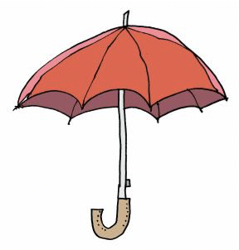
Hi, I am Storm the weather elf! I want to make myself an umbrella but I’m not sure which material is best to use. It needs to be strong and waterproof. Can you help?

★Can you find these items and test them to see if they are strong and waterproof? Put yes or no in the boxes .

Material | Strong? | Waterproof?
1. Kitchen roll
2. Plastic bag
3. Foil
4. Paper bag
5. You choose your own material:

Which is the strongest and most waterproof?

