Get creative and make your own mini umbrella for an elf!

Make sure you use the material that you found to be the strongest and most waterproof in the experiment yesterday.
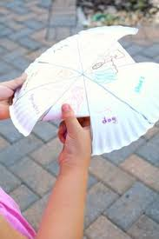
Ideas on how to make the umbrella handle:
Cardboard
A stick from outside
A lollypop or ice lolly stick
A straw

Don’t forget to take a picture and upload it for your teacher to see!

