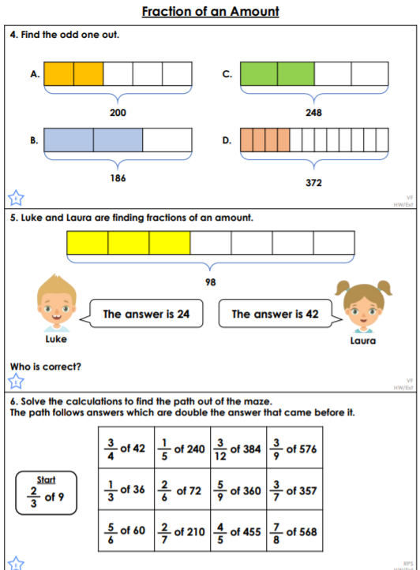<https://classroomsecrets.co.uk/fraction-of-an-amount-year-6-fractions-learning-video-clip/>

14/6 x 2 =

**Explain how you know**

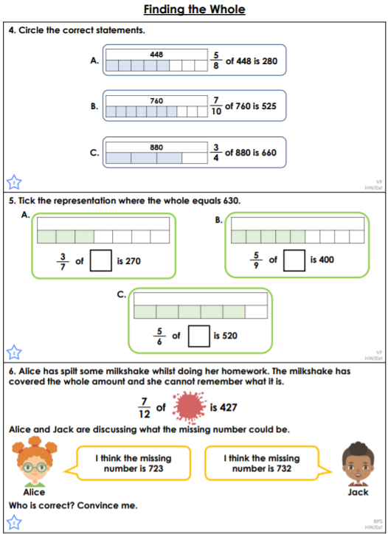 [[[<https://classroomsecrets.co.uk/finding-the-whole-year-6-fractions-learning-video-clip/>clip/](https://classroomsecrets.co.uk/finding-the-whole-year-6-fractions-learning-video-clip/)clip/](https://classroomsecrets.co.uk/four-rules-with-fractions-year-6-fractions-learning-video-clip/)video-clip/](https://classroomsecrets.co.uk/multiply-fractions-by-fractions-year-6-fractions-learning-video-clip/)

**Write**