<https://classroomsecrets.co.uk/compare-and-order-denominators-year-6-fractions-learning-video-clip/>

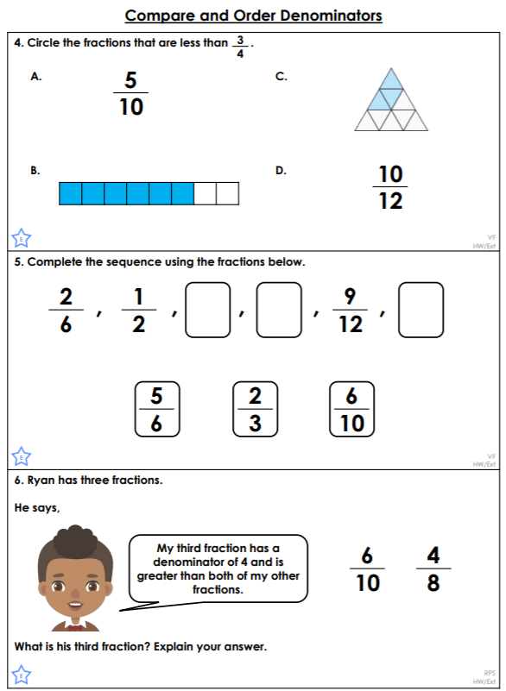

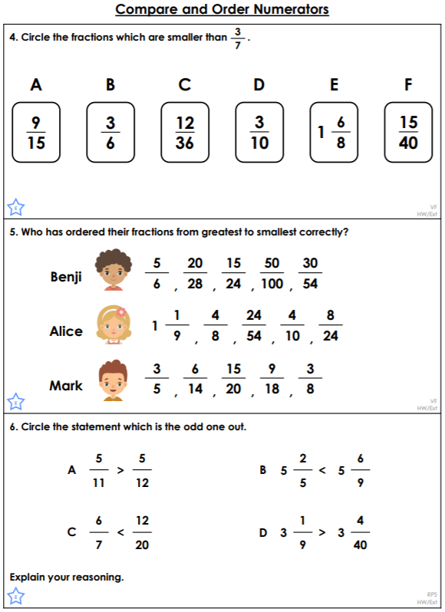<https://classroomsecrets.co.uk/compare-and-order-numerators-year-6-fractions-learning-video-clip/>