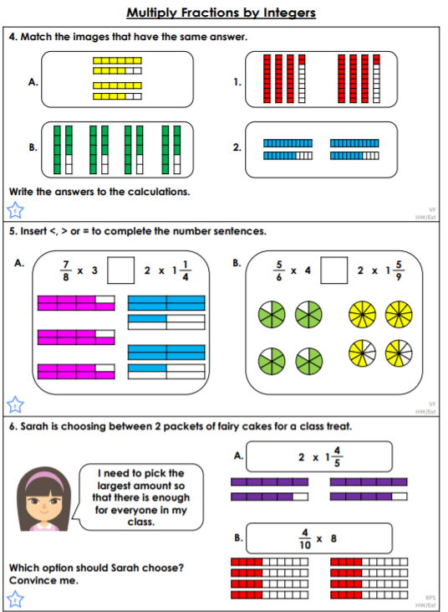<https://classroomsecrets.co.uk/multiply-fractions-by-integers-year-6-fractions-learning-video-clip/>

14/6 x 2 =

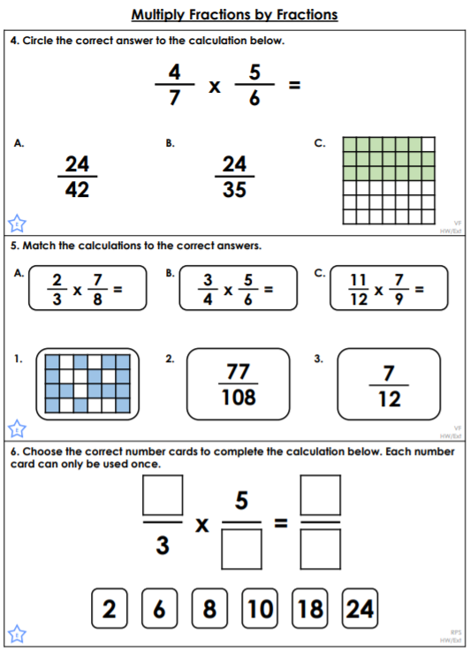 <https://classroomsecrets.co.uk/multiply-fractions-by-fractions-year-6-fractions-learning-video-clip/>

**Write**