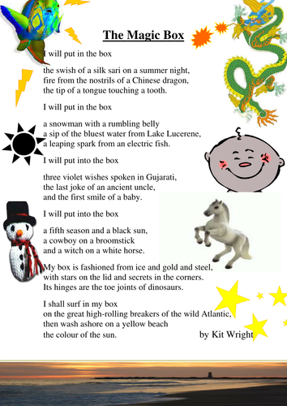**Tuesday reading (activity on next page)**

**Can you find an example of each of these poetic devices in the poem above?**

|  |  |  |
| --- | --- | --- |
| **Poetic Device** | **Definition** | **Example line in poem** |
| repetition | when a word, phrase or line is repeated for effect |  |
| onomatopoeia | when a word sounds exactly like the sound it makes – e.g. hiss, bang, splat |  |
| alliteration | when several words in a row start with the same letter – e.g. scorching summer sun |  |

Challenge: Why do authors and poets like to use these techniques in their writing?

|  |  |
| --- | --- |
| **Poetic device** | **Effect on the reader** |
| repetition |  |
| onomatopoeia |  |
| alliteration |  |

Answers below…

**Answers**

**Can you find an example of each of these poetic devices in the poem above?**

|  |  |  |
| --- | --- | --- |
| **Poetic Device** | **Definition** | **Example line in poem** |
| repetition | when a word, phrase or line is repeated for effect | *I will put in the box…* |
| onomatopoeia | when a word sounds exactly like the sound it makes – e.g. hiss, bang, splat | *swish, rumble* |
| alliteration | when several words in a row start with the same letter – e.g. scorching summer sun | *Swish of a silk sari, tip of a tongue touching a tooth* |

Challenge: Why do authors and poets like to use these techniques in their writing?

|  |  |
| --- | --- |
| **Poetic device** | **Effect on the reader** |
| repetition | It keeps key ideas in the readers’ minds so they don’t forget them. In poetry, it can also help with the rhythm. |
| onomatopoeia | It makes the writing sound more exciting. |
| alliteration | It can be a fun tongue twister, it can focus the reader on a particular part of the text and makes it more exciting. |