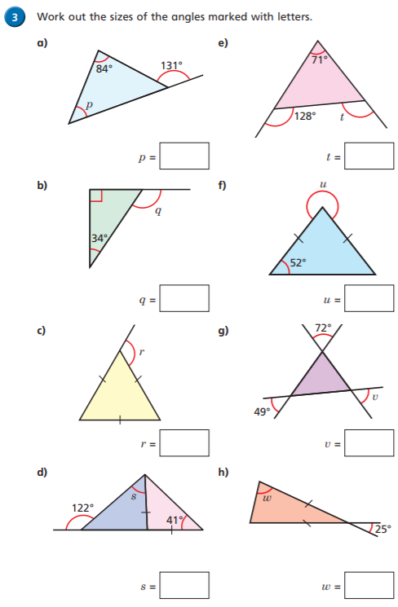Look at lesson 4 <https://whiterosemaths.com/homelearning/year-6/>

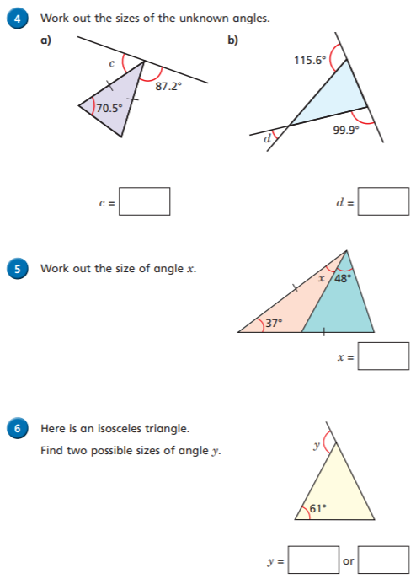

**Write**