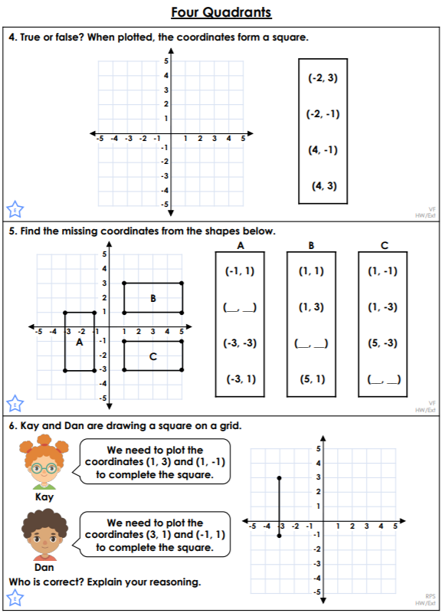<https://classroomsecrets.co.uk/four-quadrants-year-6-position-and-direction-learning-video-clip/>

