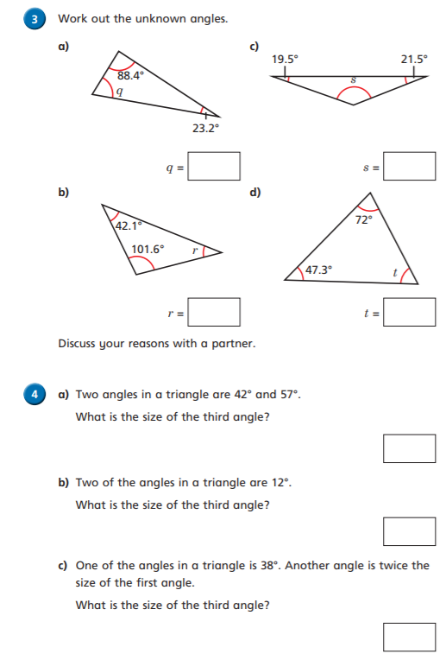Look at lesson 2 <https://whiterosemaths.com/homelearning/year-6/>

<https://whiterosemaths.com/homelearning/year-6/>

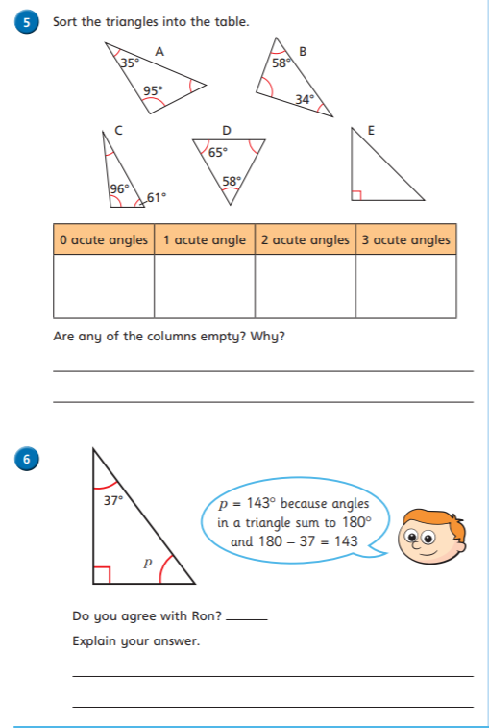

**Write**