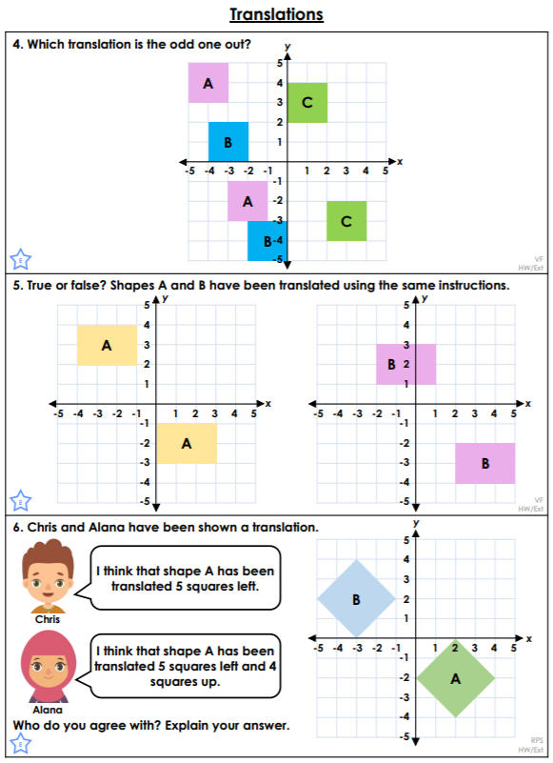<https://classroomsecrets.co.uk/translations-year-6-position-and-direction-learning-video-clip/>

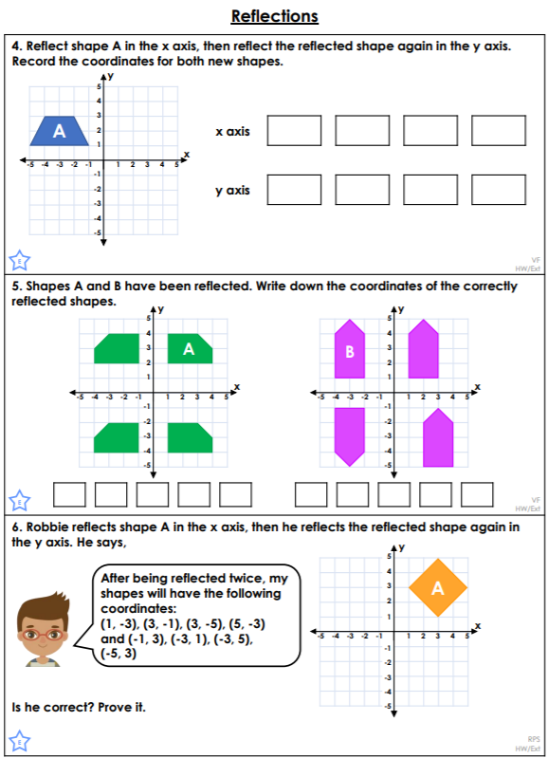<https://classroomsecrets.co.uk/reflections-year-6-position-and-direction-learning-video-clip/>