If you need further support, you can watch a video tutorial about multiplying or dividing by 10, 100 and 1000 on kids.classroomsecrets.co.uk >>> Year 6 >>> Maths >>> Decimals >>> Video tutorials.

**Monday:**

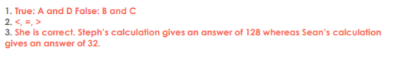

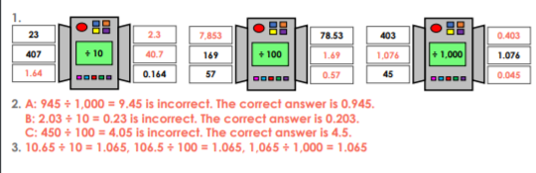

**Tuesday**

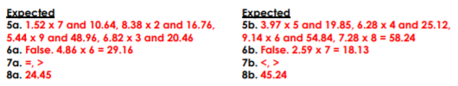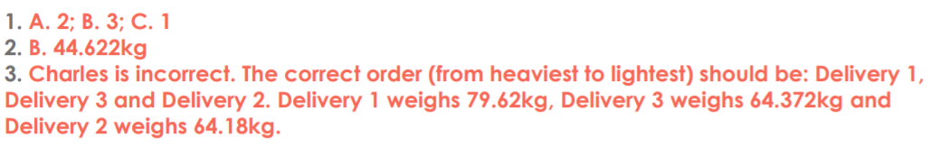

**Wednesday**

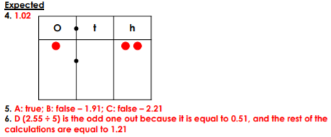

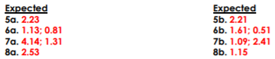

**Thursday**

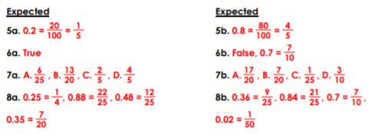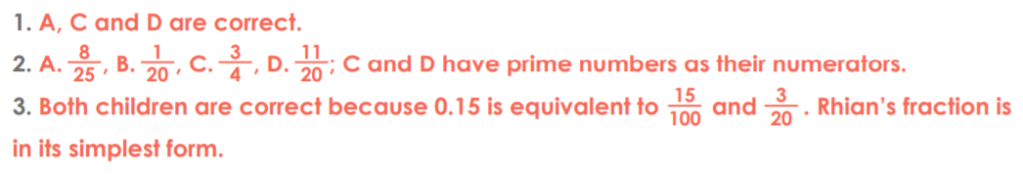

**Friday**

